# Homemade Umeshu - a Japanese plum liqueur.

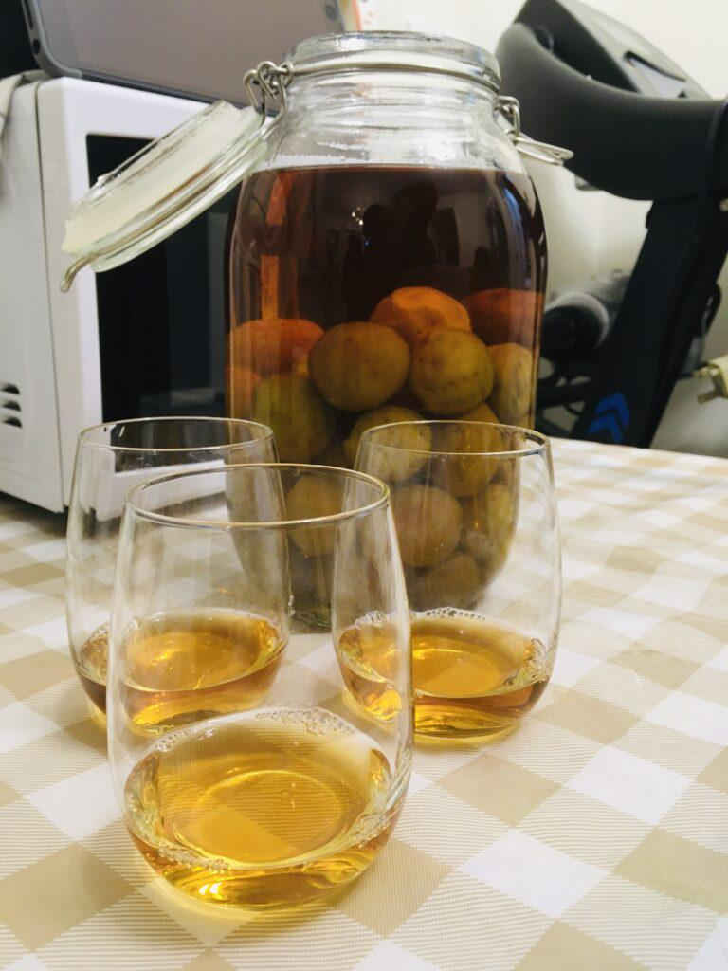

Full recipe:[ https://servedwithrice.com/homemade-umeshu/](https://servedwithrice.com/homemade-umeshu/?fbclid=IwAR2PbQWTGR4MrxOmacR8WpTK9QRhP0MYvKc3eMsvga5-JyUpojNiTVer9Sg_aem_ARty1qTYXH7kSG1mXb4Aw2claqDg4AZ7nlLDaLQteHFu2U13IScQ1Suadu8xAtDR-FwL7LhwGOoT8CpcLhBuOFBK)  
  
**Ingredients**:  
  
* 600g Ume  
* 600ml Double-distilled Chinese rice wine, or Japanese Shochu - 4 parts, in millilitres  
* 400g sugar  
  
Feel free to scale up or scale down the recipe to fit your container(s).  
  
**Instructions**  
  
1. Thoroughly wash your glass container(s), hands and other equipment.  
  
2. Wash and drain the ume. Using a fork, remove the stem and poke holes into each fruit.  
  
3. Drop the de-stemmed and hole-poked fruit into the container(s). Add the appropriate amount of sugar and cover with the corresponding amount of rice wine.  
  
4. Seal off the container(s) and leave in a cool, dark place for at least 6 months.  
  
5. After aging for a sufficiently long period of time, open and enjoy! Re-seal any leftovers and keep in a similarly cool, dark place.  
  
Enjoy!

# Choux au Craquelin (Homemade Cream Puffs)



You can see the [recipe with photos](https://yumchief.com/en/recipes/choux-au-craquelin/) on my website or a step-by-step [video on youtube](https://www.youtube.com/watch?v=pdt9XCGo4kg).  
  
**Ingredients**  
  
For the craquelin:  
  
* Butter — 33 g  
* Sugar — 40 g  
* Flour — 40 g  
  
For the choux pastry:  
  
* Butter — 60 g  
* Water — 62 ml  
* Milk — 62 ml  
* High-protein flour (11–13 g protein per 100 g) — 70 g  
* Eggs — 3 pcs  
  
For the cream filling:  
  
* Egg yolk — 2 pcs  
* Sugar — 40 g  
* Flour — 20 g  
* Milk — 200 ml  
* Cream 35% — 170 ml  
* Powdered sugar — 15 g  
  
**Directions**  
  
1. Mix 33g softened butter and 40g sugar until smooth.  
2. Add 40g flour and knead into a soft dough.  
3. Roll the dough between parchment paper to 2–3mm thickness.  
4. Freeze the rolled dough for 15 minutes.  
5. Cut out 4cm circles and return them to the freezer.  
6. Beat 3 room-temperature eggs and set aside.  
7. In a saucepan, heat 62ml water, 62ml milk, and 60g butter until melted.  
8. Bring to a boil for 10 seconds, then remove from heat.  
9. Sift 70g high-protein flour into the saucepan and mix until smooth.  
10. Return to heat and cook for 1–1.5 minutes, stirring constantly.  
11. Transfer dough to a bowl and let cool for 1–2 minutes.  
12. Gradually add beaten eggs in 4–5 additions, mixing thoroughly each time.  
13. The dough should flow off the spatula in a “V” shape.  
14. Transfer dough to a piping bag.  
15. Preheat oven to 210°C (410°F).  
16. Pipe dough onto a parchment-lined baking sheet, spacing 4–5cm apart.  
17. Place a frozen craquelin disc on each mound of dough.  
18. Bake for 10 minutes at 210°C, then reduce to 180°C (356°F) and bake for 12–15 minutes until golden brown.  
19. Let the choux buns cool completely.  
20. For the cream, mix 2 egg yolks, 40g sugar, and 20g flour until pale yellow.  
21. Heat 200ml milk to boiling, then slowly add to the egg mixture, stirring constantly.  
22. Return the mixture to the saucepan and cook over medium heat, stirring until thickened.  
23. Transfer cream to a bowl, cover with plastic wrap touching the surface, and chill in the freezer for 15 minutes.  
24. Whip 170ml heavy cream with 15g powdered sugar to soft peaks.  
25. Fold the chilled pastry cream into the whipped cream and transfer to a piping bag with a metal tip.  
26. Make a small hole in the bottom of each choux bun.  
27. Fill each bun with the cream through the hole.  
28. Refrigerate the filled buns for 1–2 hours before serving.

# Classic Burger Sauce, the go to burger sauce in our house and for good reason!

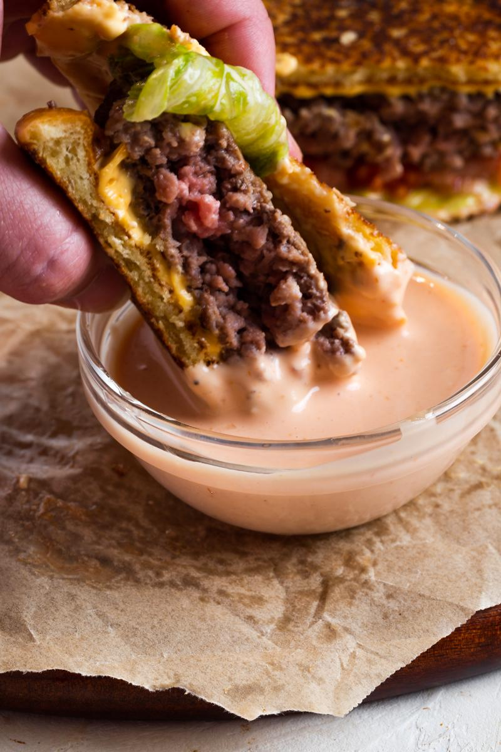

Recipe link: [https://thebutteredgnocchi.com/ultimate-easy-classic-burger-sauce-recipe-using-mayo/](https://thebutteredgnocchi.com/ultimate-easy-classic-burger-sauce-recipe-using-mayo/)  
  
# Ingredients  
  
* ¾ cup mayonnaise  
* ⅓ cup ketchup  
* 1 tablespoon white vinegar  
* 1 tablespoon pickle juice  
* 1 teaspoon garlic powder  
* 1 teaspoon onion powder  
  
# Instructions  
  
1. In a small bowl, add mayonnaise, ketchup, pickle juice and white vinegar.  
2. Add in garlic powder and onion powder.  
3. Mix until combined.  
4. Serve immediately or save for later.

# Copycat Outback Bloomin Onion Sauce

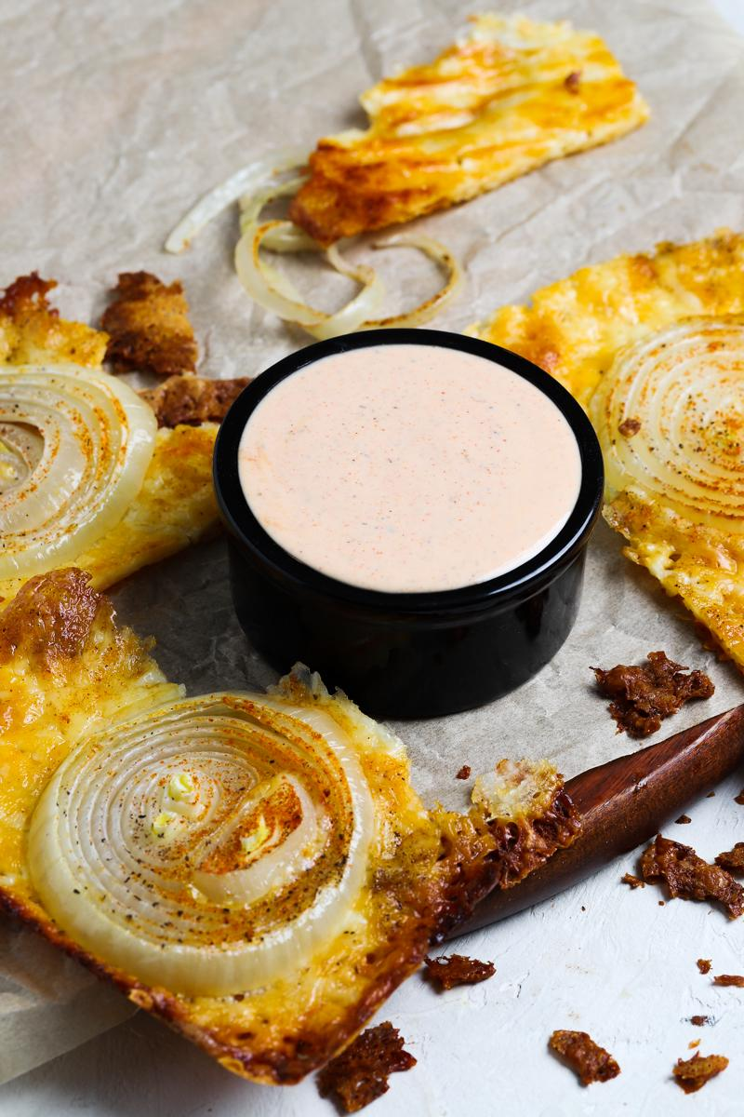

Recipe Link: [https://thebutteredgnocchi.com/copycat-outback-bloomin-onion-sauce-recipe/](https://thebutteredgnocchi.com/copycat-outback-bloomin-onion-sauce-recipe/)  
  
# Ingredients  
  
* ½ cup mayonnaise  
* ½ cup sour cream  
* ⅓ cup ketchup  
* 2 tablespoon prepared horseradish  
* 1 teaspoon garlic powder  
* 1 teaspoon paprika  
* ½ teaspoon ground red cayenne pepper  
* 1 teaspoon oregano  
* ½ teaspoon salt  
* ½ teaspoon black pepper  
  
# Instructions  
  
1. Add mayonnaise, sour cream, ketchup, horseradish, garlic powder, paprika, cayenne powder, oregano, salt and pepper to a small bowl.  
2. Mix until combined.  
3. Serve immediately or chill to serve for later.

# Smoked Pork Butt or Shoulder

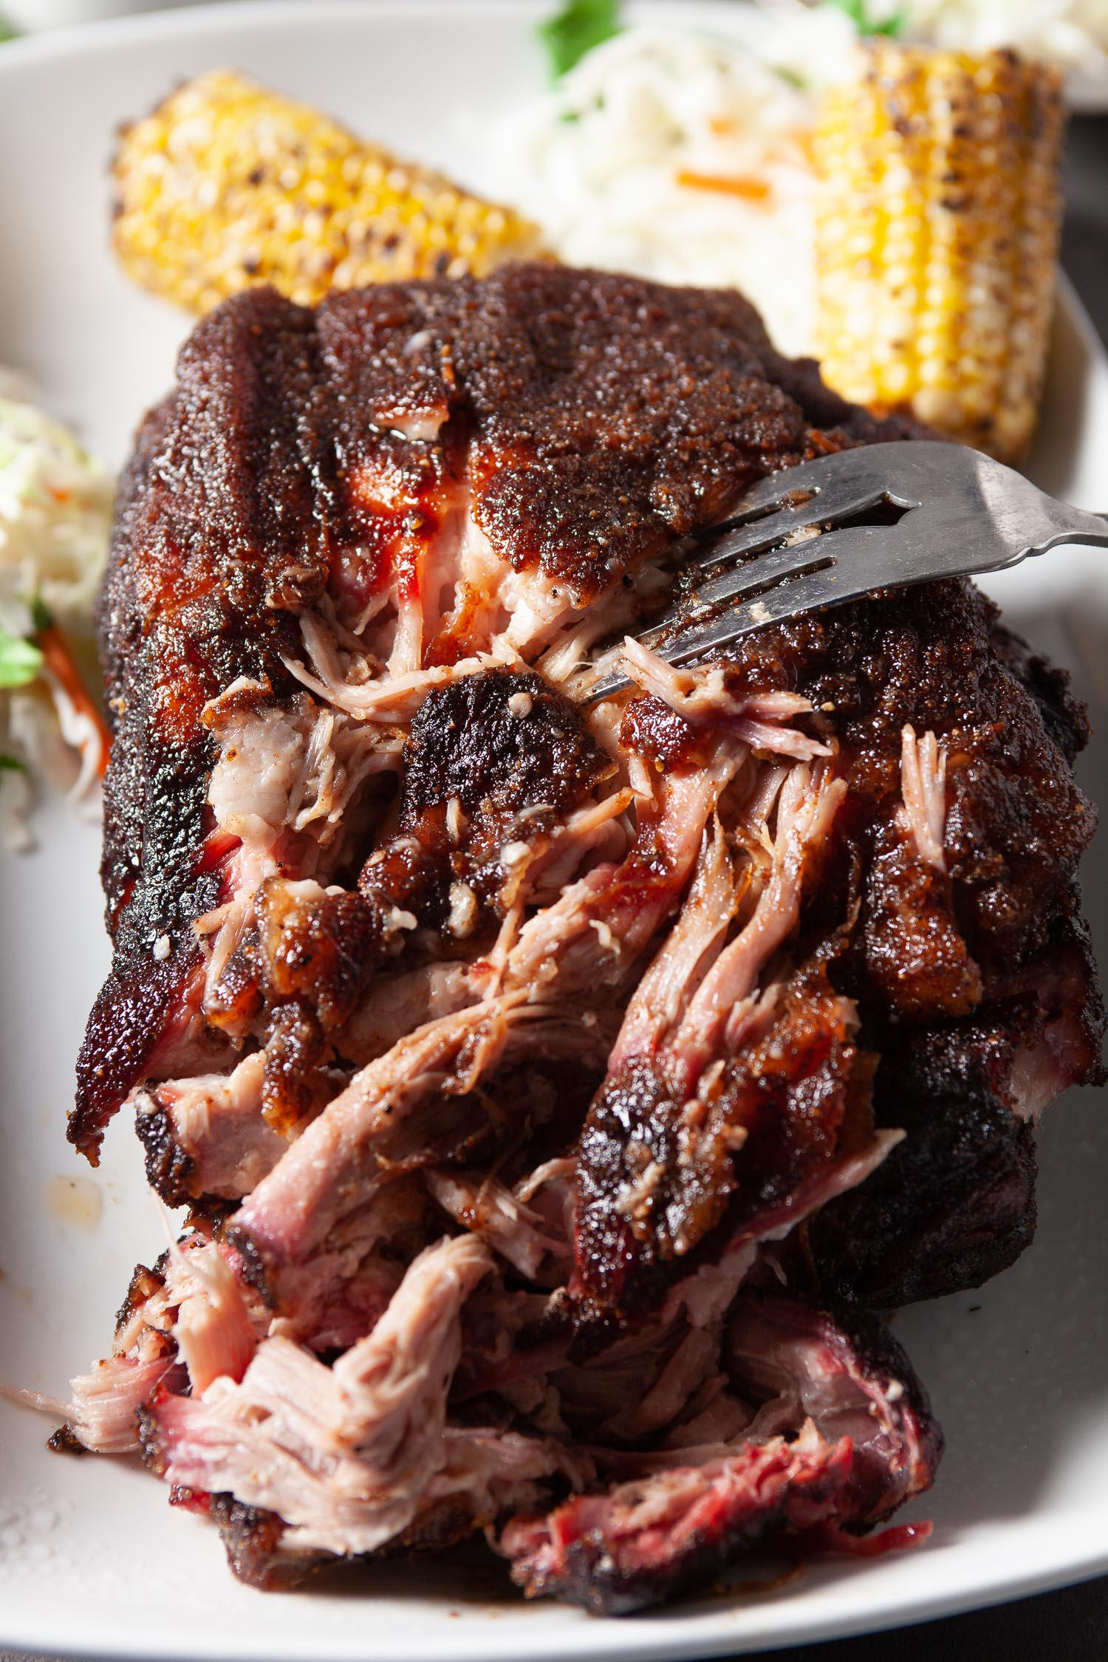

# Ingredients  
  
* 8-10 lbs Pork Butt or Pork Shoulder, bone-in  
  
For the Dry Rub:   
  
* ¼ cups brown sugar  
* 1 TB paprika, plus 1 1/2 teaspoons  
* 1 TB kosher salt  
* 1 ½ tsp black pepper, freshly ground  
* ½ tsp Cayenne Powder  
* 1 TB garlic powder  
* 1 TB onion powder  
  
# Instructions  
  
* **Prepare Ahead:** Combine all Dry Rub ingredients together in a container and stir to combine well. This can be done up to a week ahead of time. Keep in an airtight container in a cool, dry space until ready to use.  
* Preheat the smoker to 225F. Use hickory or maple wood for the smoker, or a mixture of medium-flavored woods.  
* Use clean paper towels to pat dry all sides of pork, removing as much excess moisture as possible.  
* Press dry rub onto all sides of pork roast; wear disposable gloves if you like. Depending on the size of your pork roast, you may or may not use up all the dry rub.  
* Place seasoned pork butt on the smoker, fattier side up. Insert heat-safe meat thermometer, metal probe portion only\*  
* Close lid and smoke until internal temperature reaches 201F – note that the time it takes for meat to reach this temperature can take 10-20 hours, depending on the actual temperature inside the smoker, as well as the size of the roast.  
* Place finished pork on a cutting board and loosely tent with foil. Let it rest, without cutting into it, for 30-60 minutes before shredding. This rest time is important, as it allows juices to redistribute evenly throughout the roast, preventing it from drying out.  
* Using large forks or clean hands (disposable gloves are great) pull the pork butt, removing larger pieces of fat. Serve pulled pork in a large serving bowl or on buns.  
  
Printable Recipe/Chef's Notes: [https://www.chewoutloud.com/smoked-pork-butt/](https://www.chewoutloud.com/smoked-pork-butt/)

# Dijonnaise Sauce (perfect for burgers)

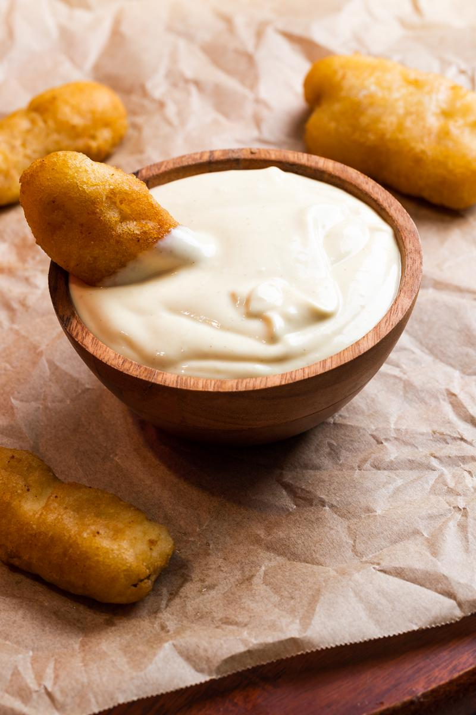

Recipe link: [https://thebutteredgnocchi.com/homemade-dijonnaise-sauce-recipe-with-dijon-mustard/](https://thebutteredgnocchi.com/homemade-dijonnaise-sauce-recipe-with-dijon-mustard/)  
  
   
One of my new favorite sauces. I have been pairing it with a lot of burgers recently but honestly it would go good on anything.  
  
# Ingredients  
  
* 1 cup mayonnaise  
* 2 tablespoon dijon mustard  
* ½ lemon juiced  
* 2 garlic cloves minced  
* ½ teaspoon salt  
  
# Instructions  
  
1. Add mayonnaise and dijon mustard to a small bowl. Mince the garlic.  
2. Juice ½ lemon into the bowl. Add in minced garlic and salt.  
3. Mix until combined.  
4. Serve immediately or chill in the fridge.

# Low Carb Onion Chips



Recipe link: [https://thebutteredgnocchi.com/easy-viral-crispy-onion-ring-chips-recipe/](https://thebutteredgnocchi.com/easy-viral-crispy-onion-ring-chips-recipe/)  
  
# Ingredients  
  
* 1 yellow onion  
* 4 oz colby jack cheese shredded  
* 4 oz mozzarella cheese shredded  
* ¼ cup parmesan cheese shredded  
* 1 teaspoon paprika  
* 1 teaspoon garlic powder  
* 1 teaspoon salt  
* 1 teaspoon pepper  
  
# Instructions  
  
1. Preheat the oven to 400 degrees. Slice the onion into thin slices, leaving the layers of the onion together.  
2. Shred the cheeses.  Spread the shredded cheese in a single layer on a baking sheet covered with parchment paper.  
3. Place the onion slices on top of the cheese evenly spaced. Add seasonings on top of the onions.  
4. Bake about 15-20 minutes or until cheese is brown and crispy and golden brown.  Break apart the onion chips and serve with dipping sauce.

# My Favorite Budget Breakfast: Egg Spread Toast

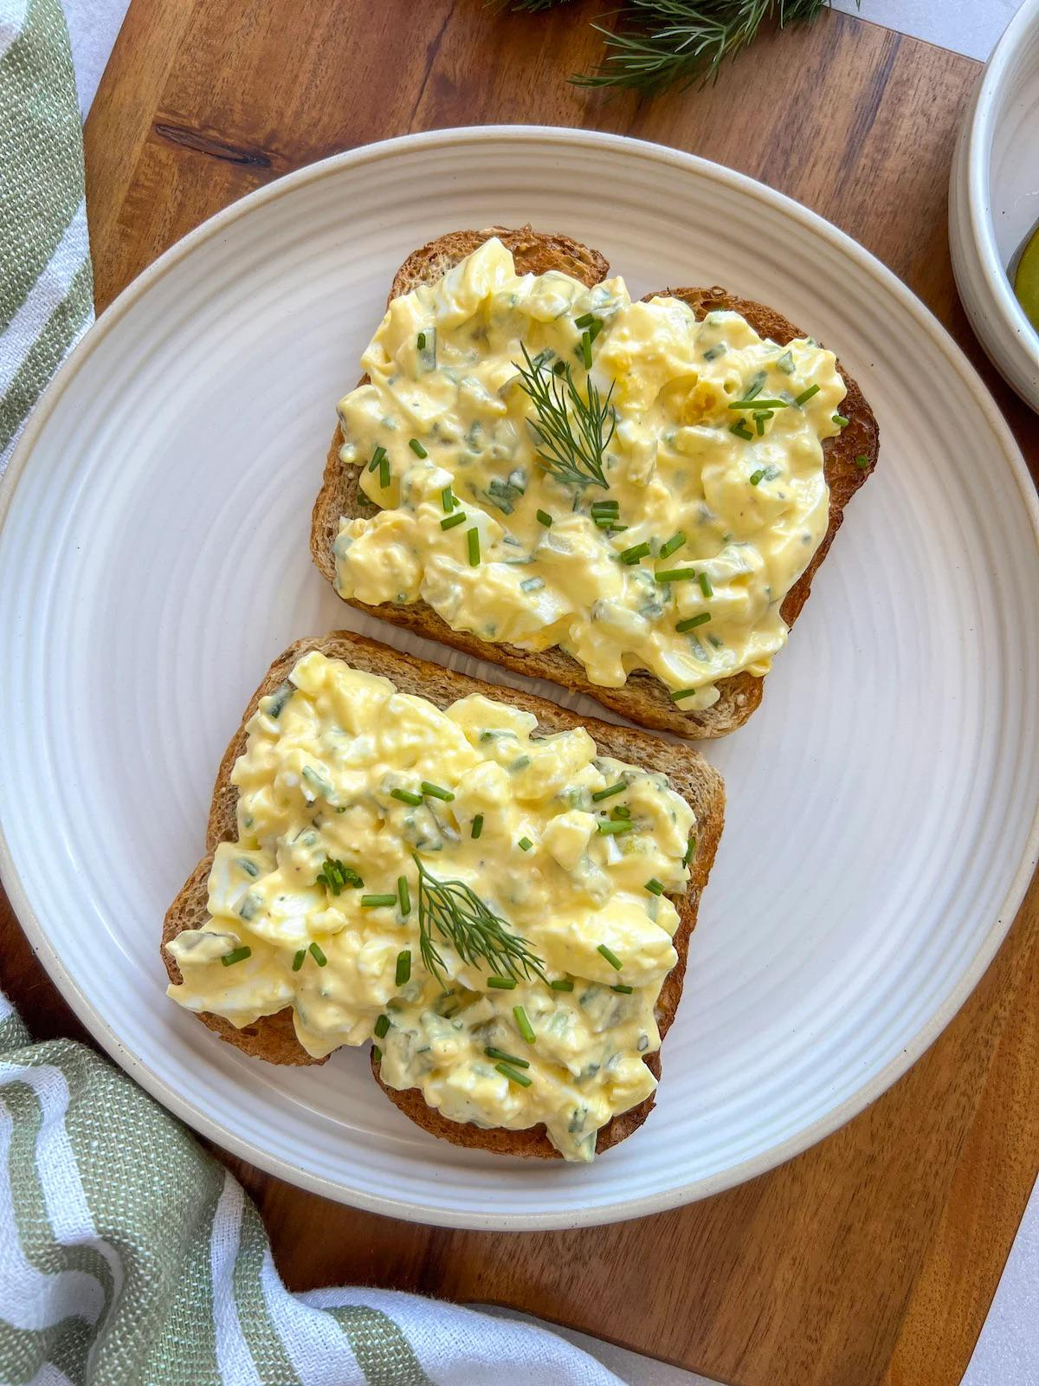

Ingredients:  
  
  
•2 hard-boiled eggs  
  
  
•2 tbsp mayonnaise  
  
  
•2 tbsp sour cream or Greek yogurt  
  
  
•1 small pickled cucumber (finely chopped)  
  
  
•1–2 tsp pickle juice  
  
  
•1–2 tbsp finely chopped onion  
  
  
•Salt and pepper to taste  
  
  
•Toasted bread  
  
  
•Optional: slices of prosciutto  
  
  
  
Instructions:  
  
  
  
  
1. Mash the hard-boiled eggs in a bowl.  
  
  
  
  
2. Add mayonnaise and sour cream (or Greek yogurt) and mix well.  
  
  
  
  
3. Stir in the chopped pickled cucumber and a bit of pickle juice.  
  
  
  
  
4. Add chopped onion, then season with salt and pepper to taste.  
  
  
  
  
5. Spread the mixture on toasted bread.  
  
  
  
  
6. Top with prosciutto if desired.  
  
  
  
  
Enjoy your quick and budget-friendly breakfast!

# Mushroom Swiss Burger

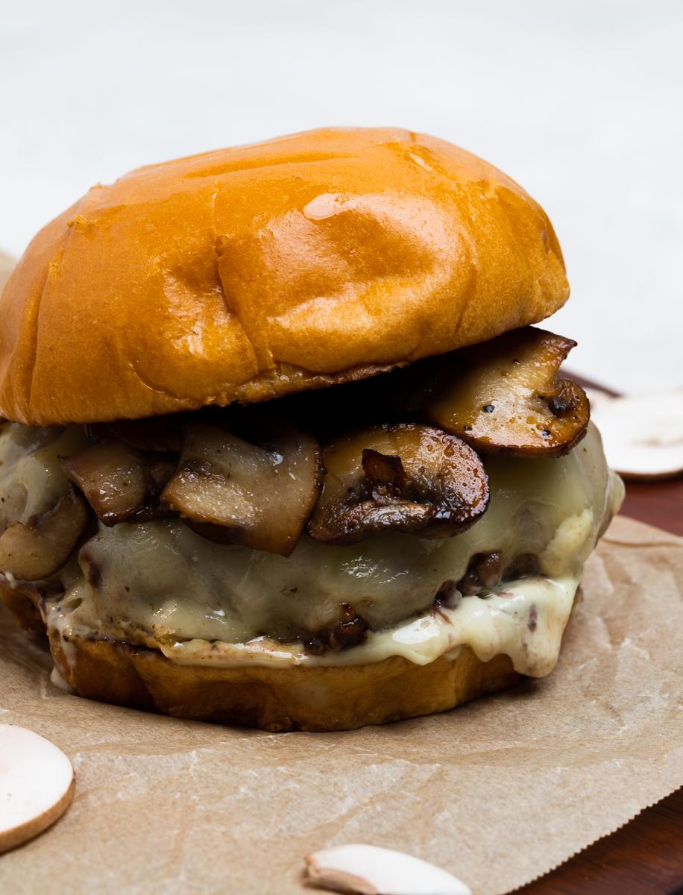

Recipe link: [https://thebutteredgnocchi.com/tasty-mushroom-swiss-burger-recipe-without-egg/Ingredients](https://thebutteredgnocchi.com/tasty-mushroom-swiss-burger-recipe-without-egg/Ingredients)  
  
* 1 lb ground beef  
* 2 cups mushrooms sliced  
* 4 slices swiss cheese  
* 4 brioche buns  
* 1 cup dijonnaise sauce  
  
# Instructions  
  
1. Slice the mushrooms.  On medium heat, sauté the mushrooms in olive oil or avocado oil until they darken in color (golden brown) and soften, about 5 minutes.  
2. Form the burger patties in your hands. Burger patties should be about 1 inch thick. Press a dimple in the middle of the burger.  
3. Cook the burger on the stove on medium-high heat for about 3-5 minutes.  Flip the burger and top with a slice of swiss cheese.  Cover the pan with a lid.  Cook until cheese is melted and desired internal temperature of the burger is reached.  
4. Place olive oil in a pan.  Toast brioche buns on medium heat, about 2 minutes.  
5. Spread dijonnaise sauce on the bottom bun.  Add the burger patty on top of the sauce.  Top with sauteed mushrooms.  Add top burger bun on top of mushrooms.  Serve immediately.

# Juicy Grilled Chicken Breast

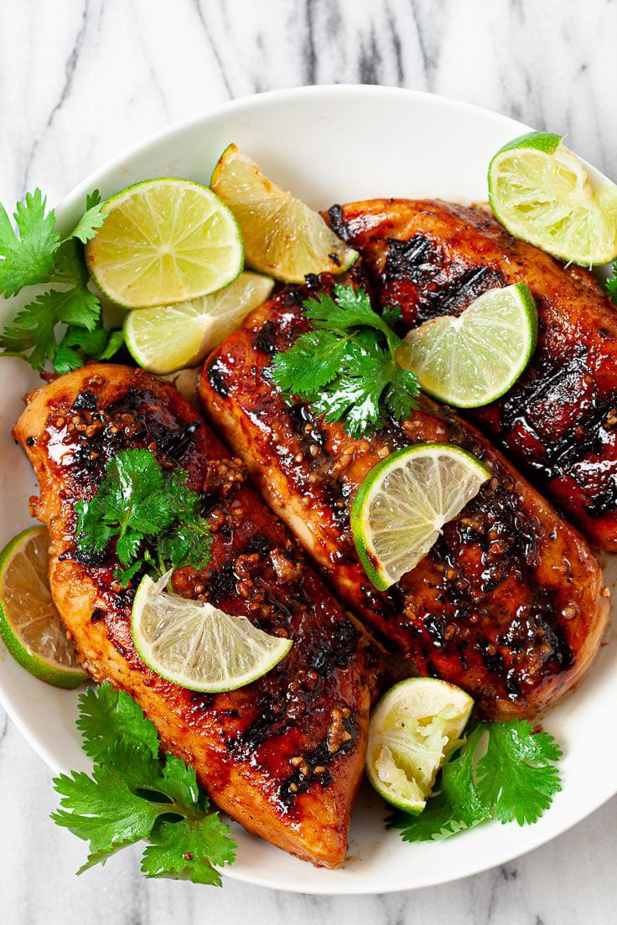

INGREDIENTS  
  
- 3 lb chicken breast, boneless and skinless  
- ⅓ cup + 2 TB pure honey  
- ¼ cup brown sugar, packed  
- ¼ cup soy sauce, regular  
- 8 cloves garlic, minced  
- 2 TB Sriracha, adjust as needed  
- Zest of 1 lime  
- 3 TB freshly squeezed lime juice  
- 1 tsp ground or freshly grated ginger  
- ¼ tsp table salt  
- Other: Oil for cooking, freshly chopped cilantro for garnish  
  
  
INSTRUCTIONS  
  
1. Dry: thoroughly dry chicken with paper towel and pierce with fork throughout. Lightly pound pieces into even thickness. Sprinkle both sides of chicken pieces with light layer of kosher salt (kosher salt is much coarser than table salt.)  
grilled chicken breast being pierced with fork  
  
2. Marinade: in a large pan or bowl, whisk together all remaining ingredients into a well-combined marinade. Reserve 1/4 cup of the marinade for later.  
Add chicken to the pan/bowl of marinade, turning to coat well. Marinade 2-3 hours, turning occasionally to re-coat.  
  
3. Grill: coat indoor or outdoor grill with oil, heating over medium-high heat until hot. Place chicken evenly on grill and cook until nice grill marks appear and center is no longer pink, approx. 4 min/side (time depends on thickness) and basting occasionally with your 1/4 cup of reserved marinade.  
  
4. Rest: let cooked chicken sit at room temp for 2-3 minutes before cutting into it. Serve immediately with freshly chopped cilantro for garnish, if desired.  
  
  
Printable recipe: https://www.chewoutloud.com/garlic-lime-grilled-chicken-2/

# Easy English Breakfast

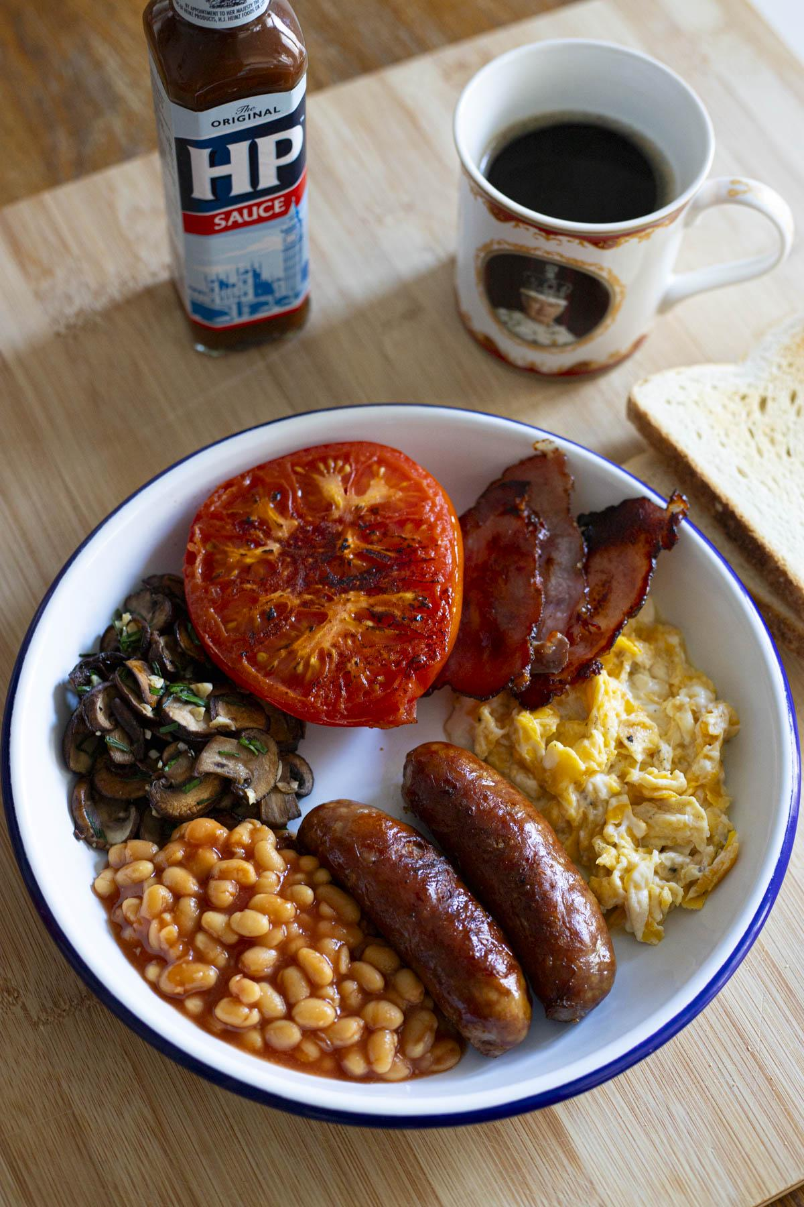

Full recipe : [https://multicarbs.com/recipe/easy-english-breakfast/](https://multicarbs.com/recipe/easy-english-breakfast/)  
  
**Ingredients (serves 2) :**  
  
* 3-4 small sausage links  
* 6 small back bacon slices (adjust depending on their size)  
* 1 can beans in tomato sauce (classic Heinz ideally)  
* 250 grams mushrooms (thinly sliced)  
* 1 tomato (halved)  
* 4 eggs  
* 4 toast slices  
* 1/2 bunch of chives (optional)  
* 1 large garlic clove (optional)  
* 2 tablespoons neutral oil  
* 2 tablespoons butter  
  
**Instructions**  
  
1. Preheat your oven at 60°C. Slice your mushrooms, mince your garlic and chives.  
2. In a pan on medium-high heat, add 1 tbsp neutral oil. Add your sausages and bacon. Cook until browned. When done, add to a plate and put it in your oven.  
3. To the same pan, using the flavoured oil with meat residues, add your mushrooms.  
4. Cook 5mn, then add salt. Cook 3 more minutes. Add garlic ; cook 1 more minute.  
5. Add chives, mix. Remove from heat and add to the oven plate.  
6. Add oil to your pan.  Add your halved tomatoes, cut side down.  
7. Sear until slightly browned. Remove & add to the oven.  
8. Start toasting 4 toasts ; I prefer using the toaster, but the English swear by frying it in the pan with oil and butter. Do as your please !  
9. Finally, finish with your scrambled or sunny side up eggs.  
10. Assemble your serving plates with each element.  
11. Add ketchup and/or HP sauce on your eggs if so wished.  
  
Cheers !

# Sun-dried Tomato Garlic and Goat Cheese Spread

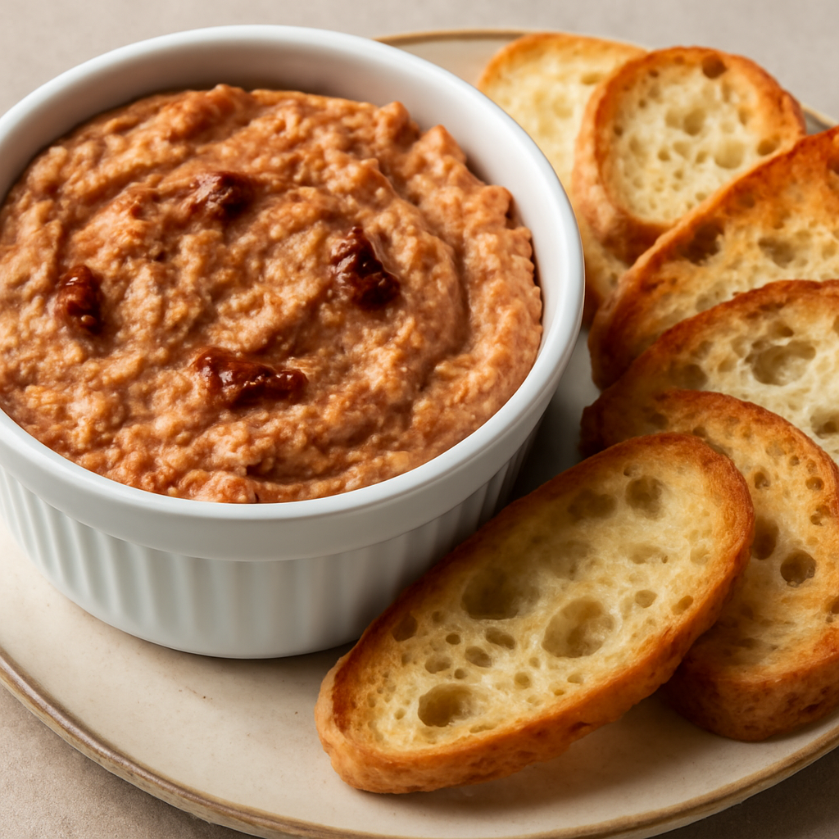

**Ingredients:**  
  
* 3 cups sun dried tomatoes (dried, not in oil)  
* 2-3 bulbs of garlic (depending on size and your love of garlic)  
* 2 Tblspns olive or avocado oil  
* 2 cups table red wine  
* 1 cup water  
* 3 4oz packages of plain goat cheese   
* 1 sliced, toasted baguette   
  
**Kitchen tools needed:**  
  
* aluminum foil  
* 3 QT saucepan  
* food processor  
* slotted spoon  
  
Instructions  
  
**Roast the garlic:**  
  
1. Preheat oven to 400°F (205°C)  
2. Cut the bulbs in half and put on a sheet of aluminum foil. Coat the cut sides with oil, then close up the garlic in the foil and bake for 30-40 minutes. Cloves should be lightly brown and soft when pressed. Once they're finished, open the foil fully and let the cloves cool completely.  
  
**Hydrate the tomatoes:**  
  
1. Put the dried tomatoes, wine, and water into the saucepan and bring to a simmer. Best to do this while the garlic is roasting. Add water if needed.   
  
**Making the spread:**  
  
1. In your food processor, add the goat cheese, the roasted garlic, squeezed from the bulbs, and use the slotted spoon to get the now hydrated sundried tomatoes. Do not drain them, you'll want the liquid to adjust the thickness of the cheese spread to your liking.  
  
2. Pulse all of the ingredients in the food processor(if yours is small, you can do this in batches). If you want the spread to be thick, and spread by a knife, you shouldn't add more than a couple of tablespoons of the simmering liquid. If you want to be able to scoop the spread with a toasted baguette slice, add another tablespoon.  
  
**Notes:**  
  
1. To save time, I usually just buy a bag of the garlic toasted baguette slices. We really like garlic in this house.  
  
2. If you have a lot of the simmering liquid left, you can use that in beef stew. I've frozen it in 1 cup silicone trays if I know it's going to be a while before I can use it. But definitely don't toss it. It's liquid gold.

# Spiced Coconut Chickpea & Roasted Veg Stew

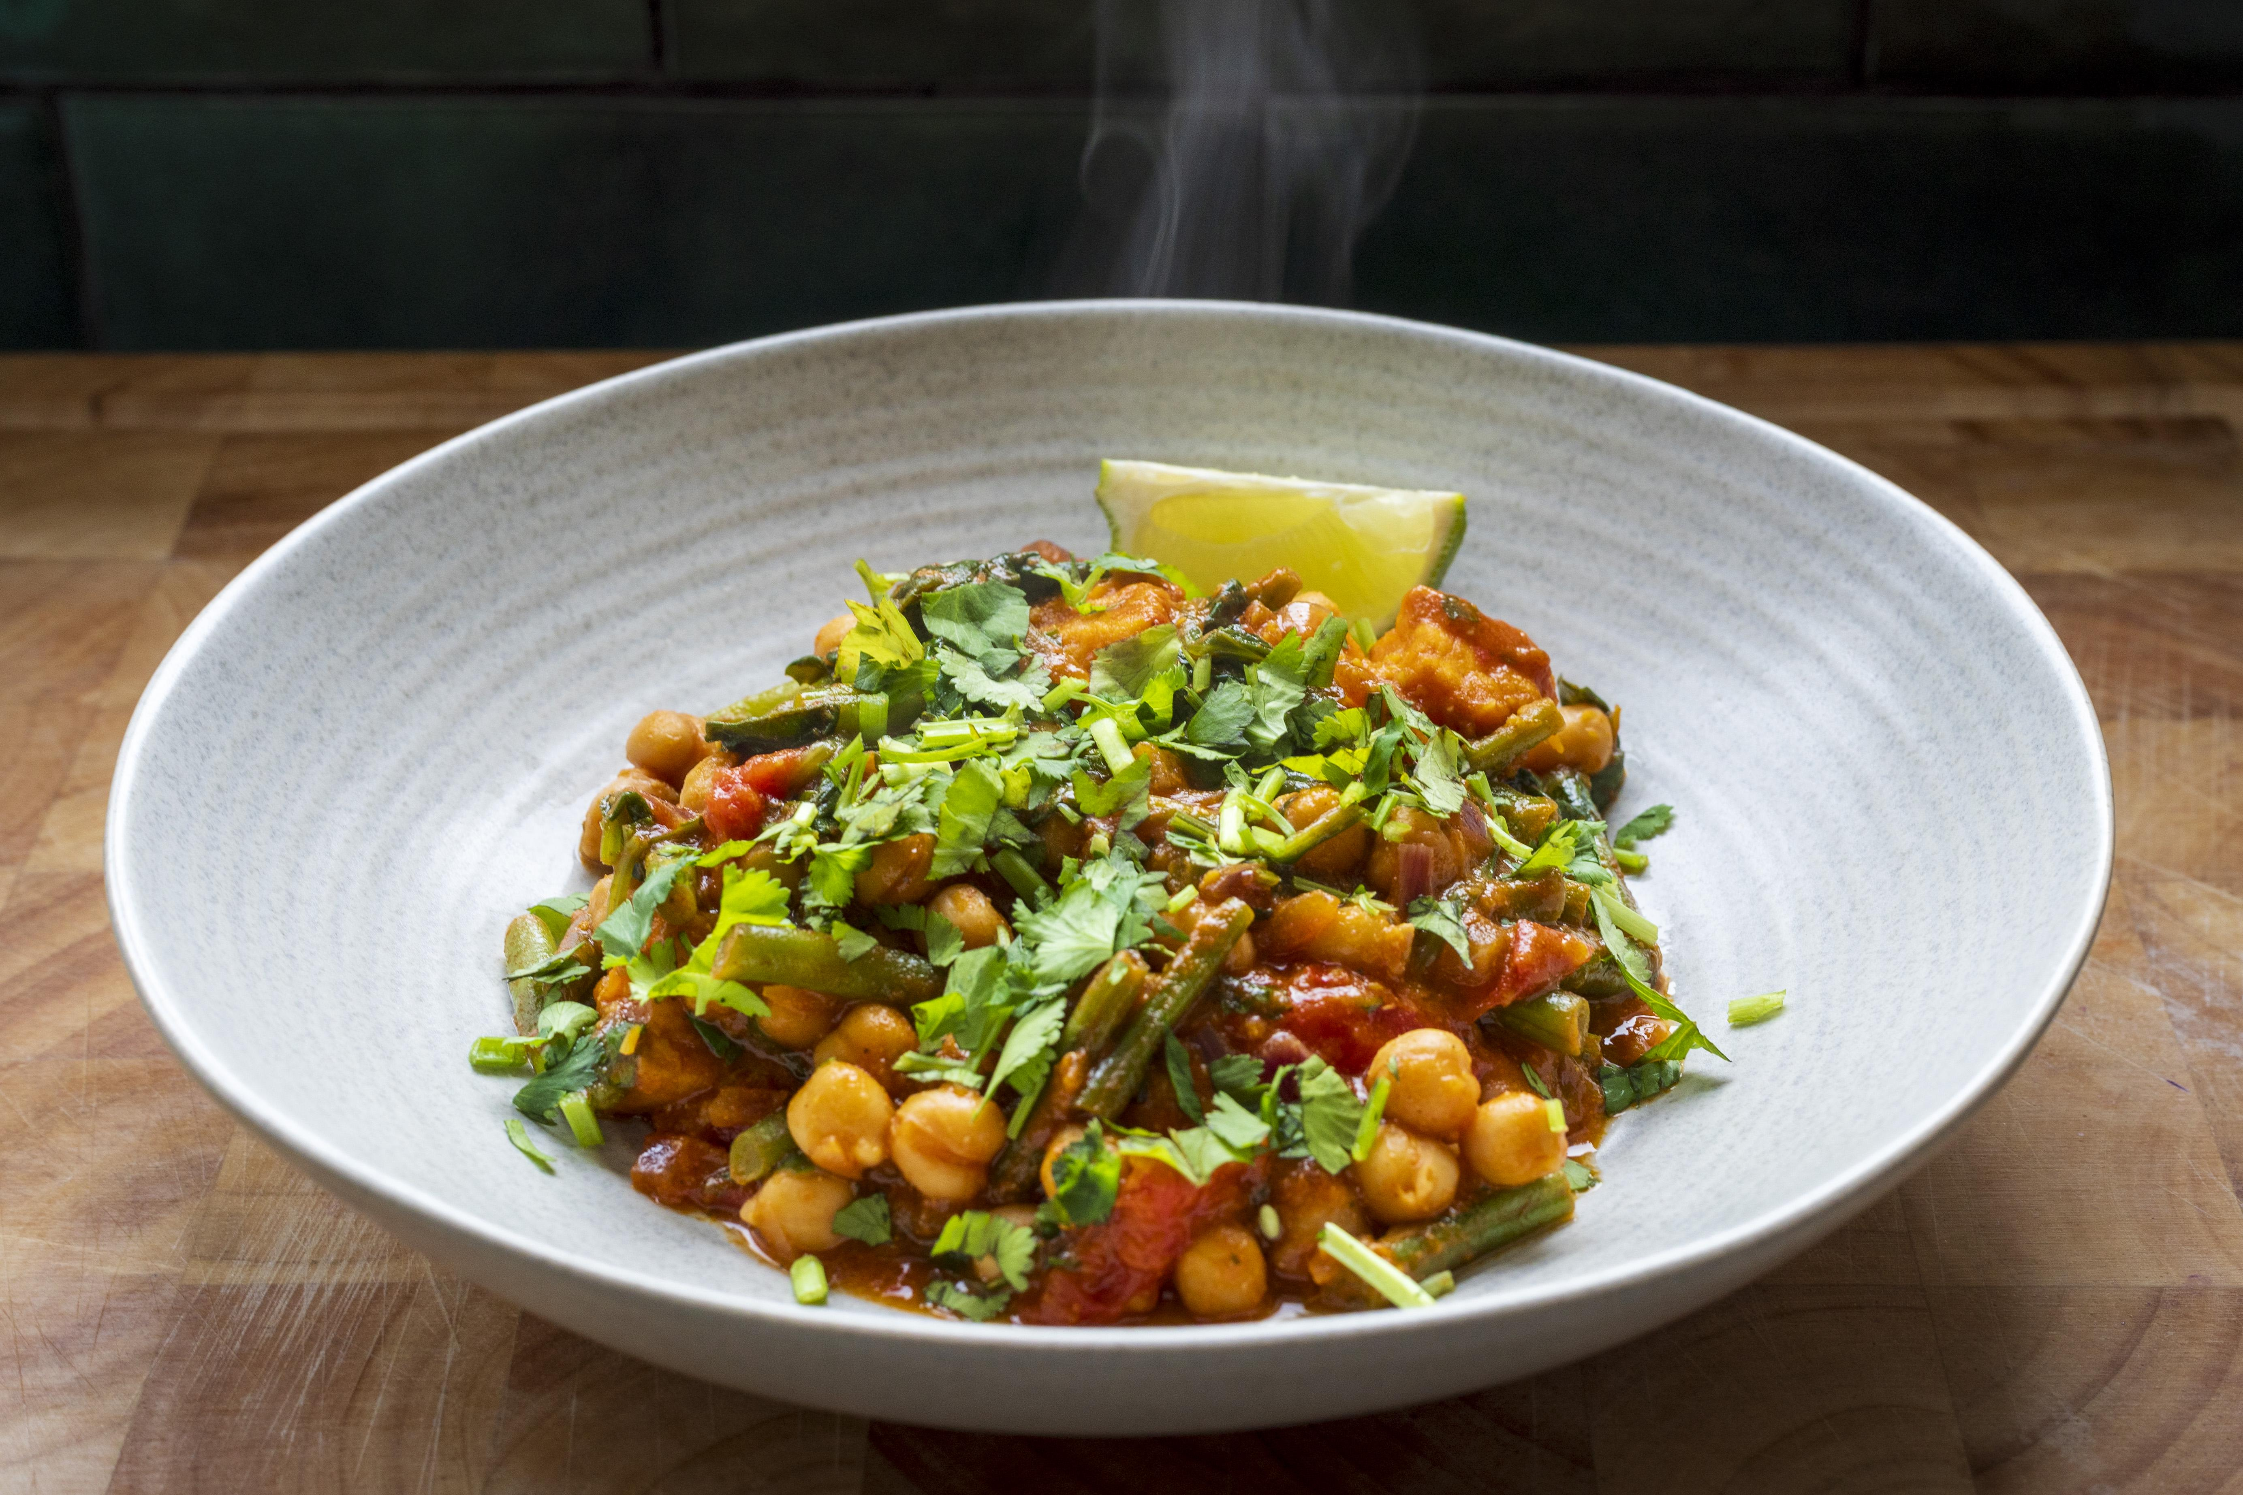

Full recipe including video: [https://cookwitheugene.substack.com/p/spiced-coconut-chickpea-and-roasted](https://cookwitheugene.substack.com/p/spiced-coconut-chickpea-and-roasted)  
  
Ingredients:   
• 1 medium sweet potato   
• 1 tbsp olive oil   
• Handful green beans, cut into thirds   
• 1 small red onion, finely diced   
• 230g tinned chickpeas, drained   
• 1 lime, halved   
• 40g creamed coconut   
• 1 tsp vegetable stock powder   
• 1 tbsp tomato paste   
• 1 tsp smoked paprika   
• ½ tsp ground cumin   
• 80g spinach   
• 4 cherry tomatoes, halved   
• Small handful fresh coriander, roughly chopped   
• A pinch of chili flakes for heat   
   
Method:   
1. Preheat oven to 220°C (fan) or 190°C for air fryer. Toss the sweet potato in olive oil, salt, and pepper. Roast on a lined tray for 20–25 mins (or air fry for 18 mins) until soft and caramelised.   
2. In a jug, dissolve creamed coconut and stock powder in 300ml hot water.Chop green beans, onion, garlic, and halve the cherry tomatoes.Set chickpeas aside, and chop coriander. Squeeze half the lime.   
3. In a pan, heat 1 tbsp oil over medium heat. Add onion and green beans. Sauté until softened, about 5–7 mins. Add tomato paste, paprika, cumin, and chili flakes. Stir in chickpeas, cherry tomatoes, and the coconut stock mixture. Simmer for 8–10 mins until thickened. Season with salt, pepper and lime juice.   
4. Add the spinach in the last 2 minutes of cooking.   
5. Fold roasted sweet potato and chopped coriander into the stew. Spoon into bowls, top with coriander and lime wedges.

# Bacon Jam Burgers

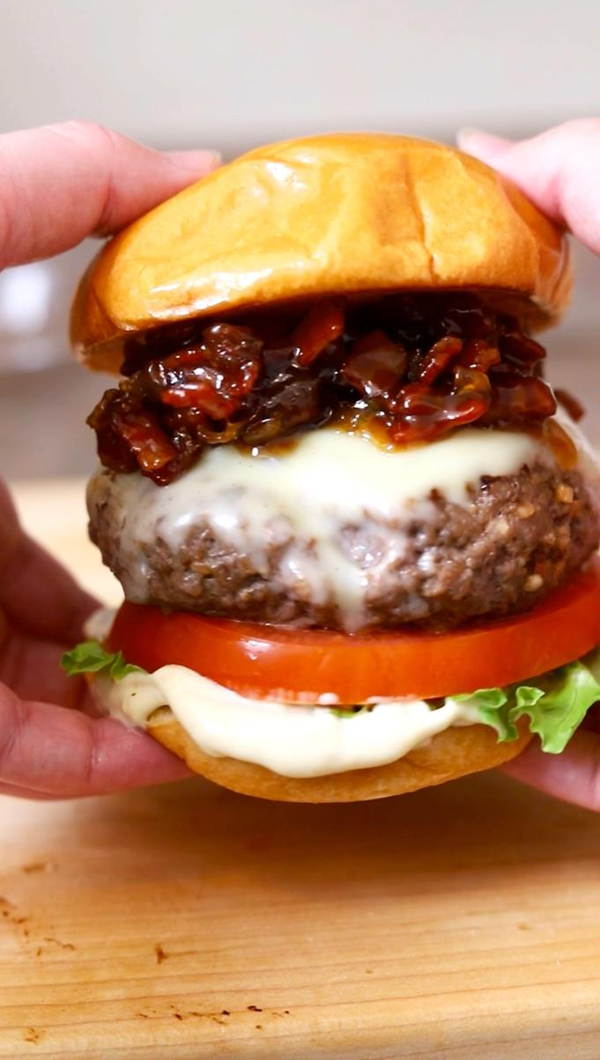

Full recipe: [Bacon Jam Burger Recipe](https://thebutteredgnocchi.com/unique-bacon-jam-burger-recipe-made-on-the-stove/)  
  
# Ingredients  
  
# Burgers  
  
* 1 lb ground beef  
* 1 packet onion soup mix  
* 1 tablespoon Worcestershire sauce  
* 4 slices American Cheese  
* 4 brioche buns  
  
# Burger Toppings  
  
* ½ cup dijonnaise sauce  
* 2 cups bacon onion jam  
* 1 tomato  
* 1 head iceberg lettuce  
  
# Instructions  
  
* In a medium bowl, mix the ground beef, onion soup mix and worcestershire sauce until combined. Form the burger patties leaving a dimple in the middle of each patty.  
* Turn the heat on the stove up to medium-high heat.  Add a little olive oil to a large skillet.  Place the burgers in the pan.  Cook about 3-4 minutes until burger is slightly caramelized and flip. Place a slice of cheese on the burger and cover.  Cook another 4-5 minutes until cheese is melted and burger is cooked to the desired temperature.  
* Slice the tomato and prep the lettuce slices. Place olive oil in a frying pan on medium heat. Place the buns in the pan face down to toast.  
* Assemble the burgers. Spread dijonaise sauce on the brioche buns. Place a slice of lettuce on the bottom bun. Place a tomato slice on top of the lettuce. Place the burger patty on top of the tomato and top with a generous amount of bacon jam. Close the burger with the top bun. Serve immediately.

# Seafood Pumpkin Soup

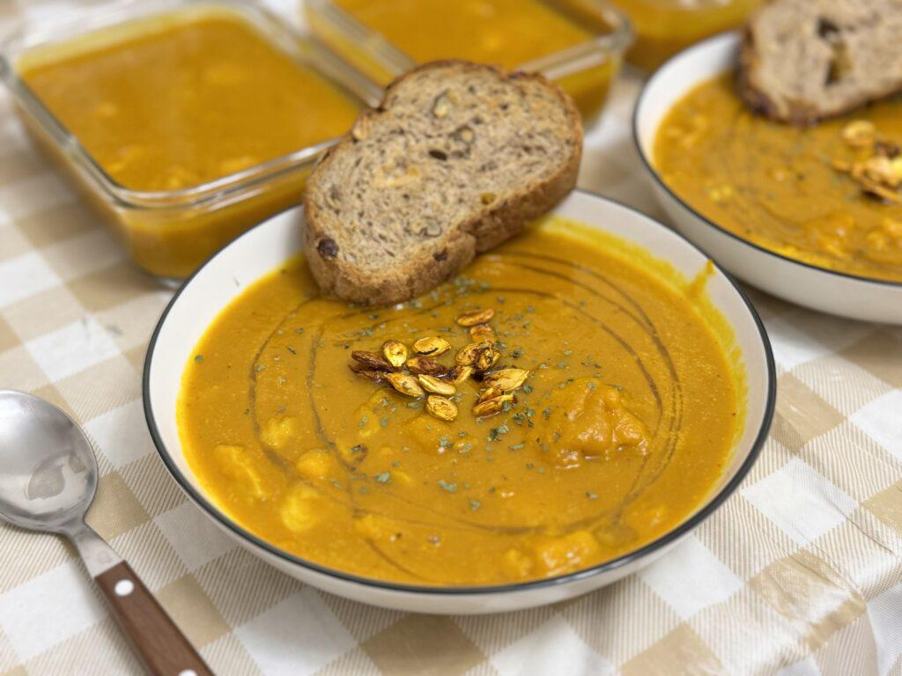

Full recipe: [https://servedwithrice.com/autumn-pumpkin-soup/](https://servedwithrice.com/autumn-pumpkin-soup/)   
  
**Ingredients (served 5):**  
  
* 3lb pumpkins   
* Pumpkin seeds  
* One onion  
* 500ml Stock  
* 900g cod  
* 5 slices of sourdough   
* Salt and pepper to taste  
* Olive oil, and herbs for garnish  
  
**Instructions**  
  
1. Preheat the oven. Halve the pumpkins, and scoop out the seeds.  
2. Roast pumpkin at 180C/350F for an hour. While pumpkin roasts, clean the fibres off of the seeds, then dice and sweat the onions.  
3. Reserve the pumpkin once it is tender. Lower the temperature and roast the pumpkin seeds at 160C/320F for 30 minutes, or until lightly brown.  
4. In the meantime, blend the onions and pumpkin in batches with some of the stock.  
5. Add stock and water to the purée, and bring to a simmer. Adjust seasoning to taste.  
6. Cube up the cod and simmer in the soup for a few minutes, or until it flakes.  
7. Toast some bread in the residual heat of the oven, and serve with the soup.  
  
Cheers!

# One Pot Kimchi Jiggae

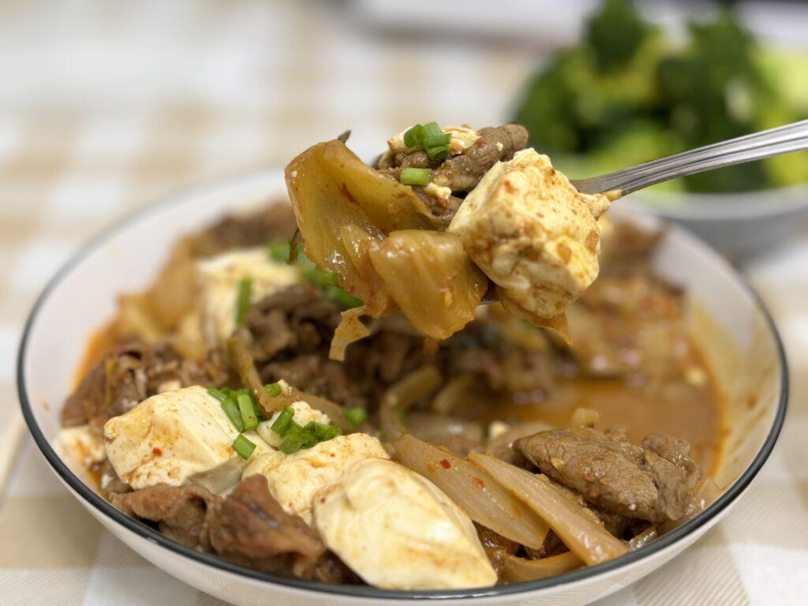

Full recipe: [https://servedwithrice.com/one-pot-kimchi-jiggae/](https://servedwithrice.com/one-pot-kimchi-jiggae/)  
  
**Ingredients (served 2):**  
  
* 300g Shabu Shabu Beef  
* 220g Tofu  
* 300g Kimchi  
* Half of a medium onion  
* 1 tbsp Gochujang  
* Sugar and sesame oil to taste  
* Spring onions for garnish  
  
**Instructions**  
  
1. Cut onions and kimchi.  
2. Stir fry onions until slightly wilted. Add kimchi and stir fry until aromatic.  
3. Add water and gochujang, along with the beef. Bring to a simmer, stirring to separate the beef.  
4. Once at a simmer, add tofu and cover. Simmer for 10-15 minutes.  
5. Drizzle with sesame oil once the heat is off, and serve. Garnish with spring onions.  
6. Serve hot, with rice.  
  
Cheers!

# Vietnamese Baguette (Banh Mi)

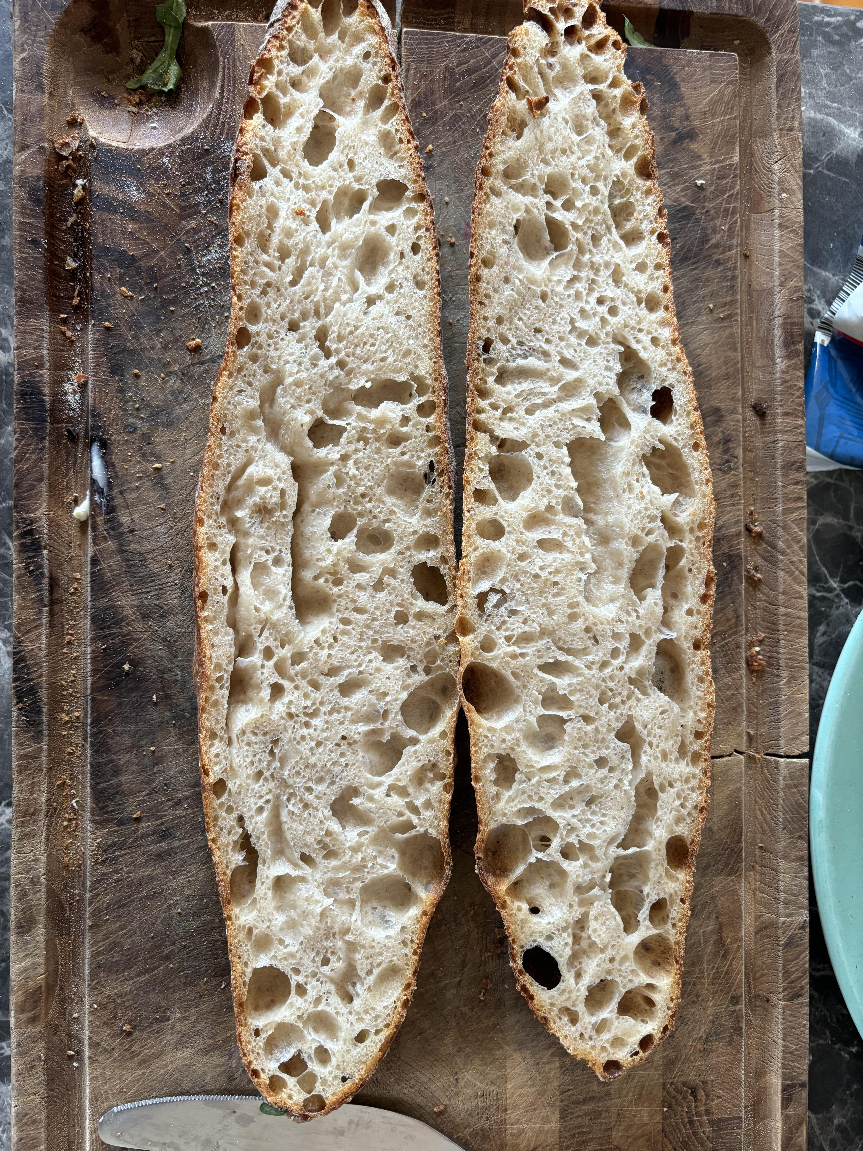

## Vietnamese Baguette (Bánh Mì)  
  
[Link to Recipe (kokkey.com)](https://www.kokkey.com/recipe/vietnamese-baguette-banh-mi-apronyoutube)  
  
  
### Ingredients  
- **Bread flour** – 200g (or 1 cup + 5 tablespoons)  
- **Sugar** – 1.5g (or 1/2 teaspoon)  
- **Salt** – 1.5g (or 1/4 teaspoon)  
- **Instant yeast** – 3g (or 1 teaspoon)  
- **Water** – 140ml (70%)  
- **Olive oil** – as needed (watch the video for details)  
  
  
### Instructions  
1. **Prepare Dough**:   
 In a large mixing bowl, combine bread flour, sugar, salt, and instant yeast. Gradually add water and mix until a dough forms.  
   
2. **Knead Dough**:   
 Knead the dough on a lightly floured surface until smooth. Add olive oil as needed during the kneading process.  
   
3. **First Rise**:   
 Place the dough in a greased bowl, cover, and let it rise until doubled in size.  
   
4. **Shape and Second Rise**:   
 Punch down the dough, shape it into a baguette, and let it rise again until puffy.  
   
5. **Bake**:   
 Bake in a preheated oven at 230°C (440°F) for 17–20 minutes, or until golden brown.

# Weeknight Sourdough Bruschetta

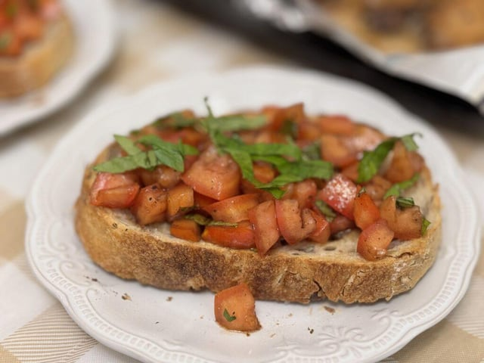

Full recipe: [https://servedwithrice.com/simple-pleasures-weeknight-sourdough-bruschetta/](https://servedwithrice.com/simple-pleasures-weeknight-sourdough-bruschetta/)  
  
**Ingredients (served 2):**   
  
* 2 slices sourdough  
* 1 clove garlic  
* 1 medium tomato  
* A few basil leaves  
* 2 tbsp olive oil  
* 1 tsp balsamic vinegar  
* Salt and pepper to taste  
  
**Instructions:**  
  
1. Clean and quarter the tomato. Cut out the core, seeds and gel. Finely dice.   
2. Wash and slice basil leaves into tiny ribbons.  
3. Mix diced tomatoes in salt, pepper, basil, olive oil and balsamic vinegar. Refrigerate while preparing the other ingredients.  
4. Gently toast the bread (for example, 3 minutes at 150C/300F in the oven).  
5. Remove bread from the heat. Once cool enough to handle, rub the peeled garlic clove against one surface of each piece.  
6. Drizzle the bread with oil, sprinkle it with salt, then top with the tomato mixture and serve.  
  
Cheers!

# One Pot Bolognese Cheesy Pasta Bake

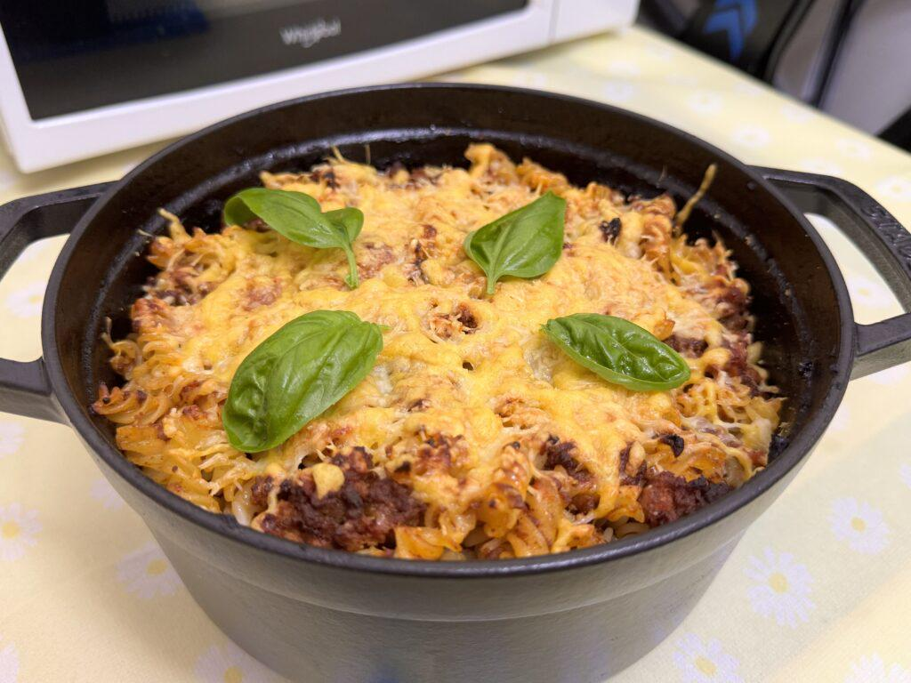

Full recipe: [https://servedwithrice.com/bolognese-pasta-bake/](https://servedwithrice.com/bolognese-pasta-bake/)   
  
**Ingredients (served 4)**  
  
* 250g ground beef, 85% lean  
* 250g ground pork  
* Quarter of a medium onion  
* Half of a small carrot  
* 400g canned peeled tomatoes  
* 1 tsp tomato paste  
* 1 tbsp Better than Bouillon beef stock paste  
* 250g fusilli, or pasta of choice  
* 1 bay leaf  
* 50g shredded mature Cheddar  
* 50g shredded Parmesan  
* Salt and pepper to taste  
  
**Instructions**  
  
1. Preheat the oven to 180C/350F. Dice the carrot and onion.  
2. Brown the beef and pork in a 22 inch Dutch oven, working in batches. Reserve the meat. Saute the vegetables and the tomato paste in the same pot.  
3. Add meat back into the pot, along with the canned tomatoes, bay leaves, and Better than Bouillon. Plus some water if needed.  
4. Bring the pot to a simmer, cover with the lid, and bake in the oven for 2 to 3 hours.  
5. Just before the sauce is done, cook pasta according to package instru and drain well. Measure out the cheese.  
6. Mix the pasta and half of the cheese into the sauce. Top with the rest of the cheese, and bake uncovered for 20 minutes or until cheese is melted and slightly browned.  
7. Allow to cool slightly before plating, garnishing and serving.  
  
Cheers!

# Zesty Lemon Butter Fish Fillet



**Ingredients**  
  
Servings : 4   
  
For the Fish   
- 4 white fish fillets (cod, tilapia, or haddock)   
- 1 teaspoon paprika   
- 1 teaspoon garlic powder   
- 1 teaspoon onion powder   
- 2 tablespoons olive oil   
- Salt and pepper, to taste   
  
For the Lemon Butter Sauce  
- 4 tablespoons butter   
- 2 tablespoons olive oil   
- Juice and zest of 2 lemons   
- 4 cloves garlic, minced   
- 1 tablespoon fresh parsley, chopped   
- Salt and pepper, to taste   
  
**Directions**  
   
1. Prepare the Fish:   
 - Pat the fish fillets dry with paper towels. Rub both sides with olive oil. Season evenly with paprika, garlic powder, onion powder, salt, and pepper.   
 - Heat a large skillet over medium-high heat. Add the fish and cook for 3–4 minutes per side, until golden and flaky. Remove and set aside.   
  
2. Prepare the Lemon Butter Sauce:   
 - Using the same skillet, reduce heat to medium. Add butter and olive oil. Once melted, stir in garlic and cook for 1–2 minutes until fragrant.   
 - Add lemon juice, zest, and parsley. Season with salt and pepper. Simmer for 2–3 minutes.   
  
3. Assemble and Serve:   
 - Place cooked fish on a platter. Drizzle with warm sauce.   
 - Garnish with extra parsley and lemon slices.   
  
  
Prep Time : 10 minutes   
Cook Time : 15 minutes

# Garlic Butter Whole Roasted Chicken

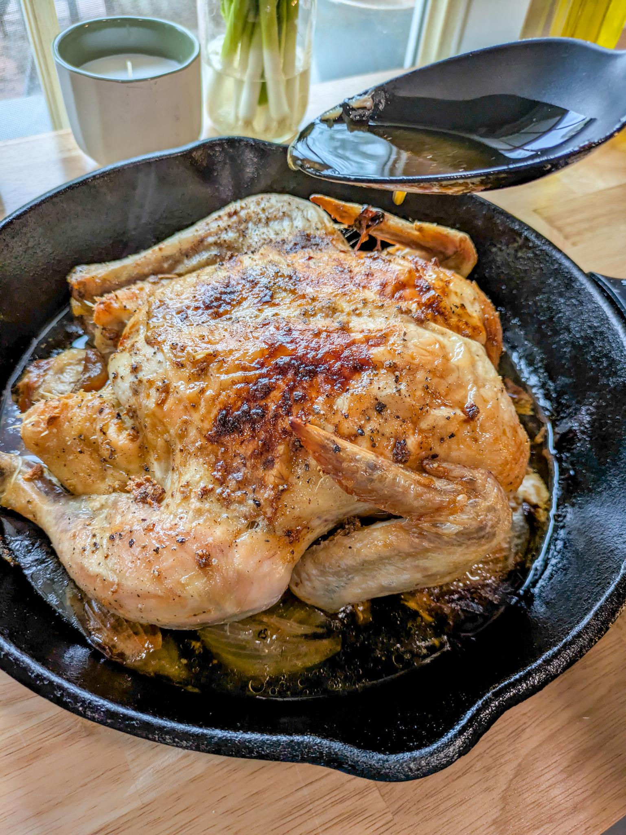

This is a super easy chicken recipe that roasts low and slow and comes out really tender and juicy.  
  
Ingredients  
  
* 4-5 Pound Whole Chicken  
* 3 tbsp Butter  
* 2 tbsp Olive Oil  
* 2 tsp Salt  
* 1 tsp Pepper  
* 3 Cloves of garlic, minced or grated  
* 1-2 onions quartered  
  
# Instructions  
  
* **Preheat** your oven to 325°F. Prepare your roasting pan or a large cast-iron or heavy pan by laying out the quartered onions in a circle on the bottom of the pan.  
* **Pat the chicken dry** with paper towels and place it on top of the quartered onions.  
* **In a small bowl**, mix together the olive oil, minced garlic, salt, and pepper. **Rub the garlic oil mixture** generously all over the chicken — including under the skin and inside the cavity if possible.  
* Add the 3 tablespoons of butter to the top of the chicken and r**oast** uncovered for 2.5 hours, or until the internal temperature reaches 165°F and the skin is deeply golden and crisp.  
* **Let rest** for 10–15 minutes before carving to lock in all the juices.  
  
pictures and details: [https://unapologeticeats.com/garlic-butter-whole-roasted-chicken/](https://unapologeticeats.com/garlic-butter-whole-roasted-chicken/)

# Crispy Parmesan Chicken Fritters



Recipe here originally: [Crispy Parmesan Chicken Fritters](https://cookingfrog.com/parmesan-chicken-fritters/)  
  
# Ingredients:  
  
*(Serves 3–4)*  
  
* **1.5 lbs (about 680g)** chicken breast or turkey breast, finely diced  
* **4 large eggs**  
* **1 tablespoon Dijon mustard**   
* **2½ tablespoons olive oil**  
* **¼ cup freshly grated Parmesan cheese**  
* **3 tablespoons flour** (use 1½ tbsp cornmeal + 1½ tbsp all-purpose flour for great texture) Use almond flour for keto version  
* **1 teaspoon dried oregano**  
* **¼ teaspoon garlic powder**  
* **¼ teaspoon ground black pepper**  
* **⅓ teaspoon curry powder**  
* **1¼ teaspoons sea salt** (or to taste)  
* **⅓ teaspoon baking powder**  
* **Neutral oil for frying** (around 1 cup, depending on your pan)  
  
#  Instructions:  
  
1. **Dice the Chicken:** Cut the chicken into small, uniform cubes for even cooking and easy mixing.  
2. **Whisk the Batter:** In a large bowl, beat the eggs. Mix in mustard, olive oil, Parmesan, and all the spices (oregano, garlic powder, pepper, curry, and salt). Add flour and baking powder and whisk until smooth and lump-free.  
3. **Mix & Chill:** Fold in the chicken pieces, making sure they’re well coated. Cover and chill in the fridge for at least 1 hour — or overnight for even better flavor.  
4. **Fry the Fritters:** Heat oil in a non-stick skillet over medium. Once hot, lower the heat slightly. Drop spoonfuls of the mixture into the oil and gently flatten. Fry for 3–4 minutes per side or until golden brown and fully cooked.  
5. **Drain & Serve:** Let rest on paper towels to drain any excess oil. Serve warm with a yogurt-based dip, aioli, or your favorite sauce.

# Spicy Cumin Lamb Wraps

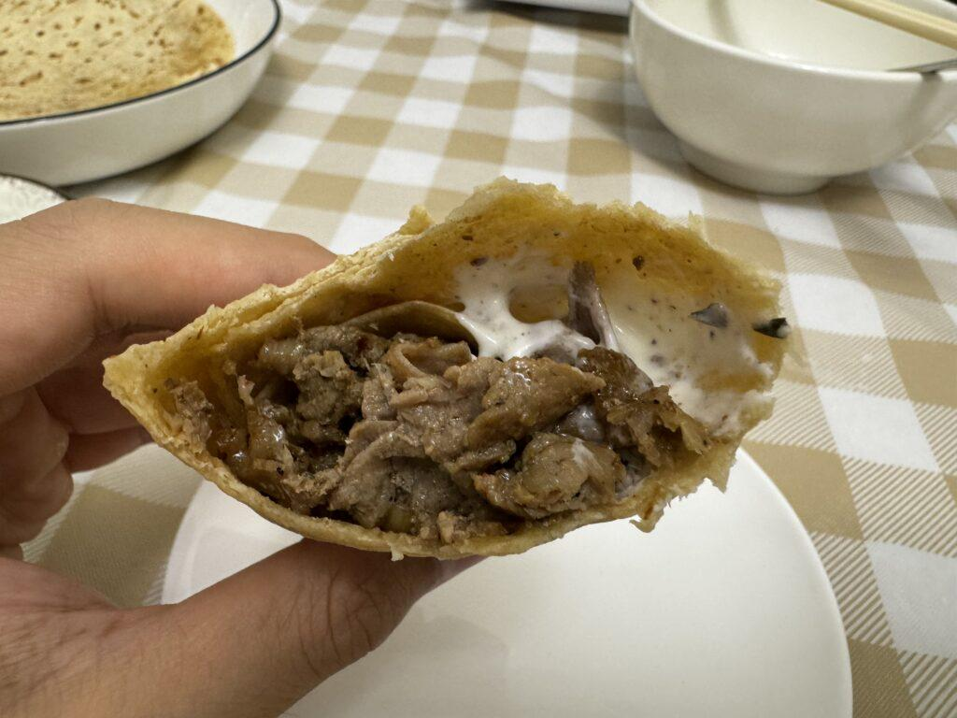

Full recipe: [https://servedwithrice.com/cumin-lamb-wraps/](https://servedwithrice.com/cumin-lamb-wraps/)   
  
**Ingredients (served 2)**  
  
* 300g thinly sliced lamb shoulder  
* 4 pieces of tortilla, or other flatbread  
* 1 tbsp soy sauce  
* 1 tsp Shaoxing wine  
* 2 tsp cumin  
* 1 tsp Szechuan peppercorns  
* 4 cloves of garlic  
* 2 shallots  
* Chili powder to taste  
  
*For the sauce*  
  
* 1 tbsp powdered Ranch  
* 1/2 cup plain yogurt  
* 1 tbsp mayonnaise  
* 1 tsp lemon juice  
  
**Instructions**  
  
1. The night before, marinade the lamb. Cover and leave in the fridge overnight.  
2. Warm up the flatbread gently in a low oven. Mix up the sauce.  
3. In a frying pan, stir fry the lamb until cooked.  
4. Assemble and serve.  
  
Cheers!

# Easy Honey Baked Ham [oc]

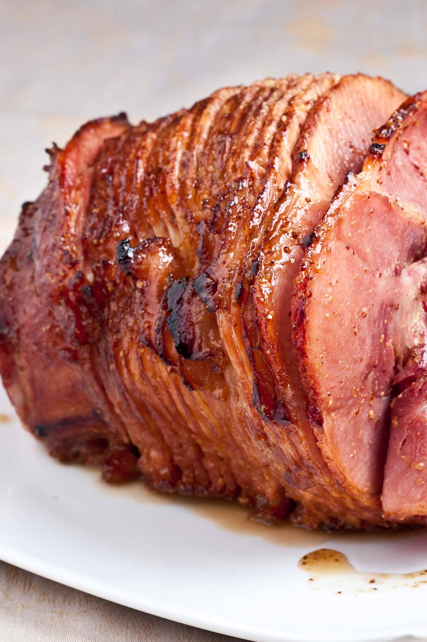

Printable Recipe: [https://www.chewoutloud.com/honey-baked-ham/](https://www.chewoutloud.com/honey-baked-ham/)  
  
# Ingredients  
  
* 4-5 lbs ham, spiral-sliced, fully cooked  
* 1 cup apple cider (sweet juice, not vinegar)  
* ¼ cup brown sugar, firmly packed  
* ¼ cup whole grain mustard (country style, contains whole mustard seeds) =  
* ¼ cup honey  
  
# Instructions  
  
1. Heat oven to 350F with rack on lower position.  
2. Mix together apple cider, brown sugar, mustard, and honey in a bowl. Mix well to fully incorporate basting sauce.  
3. Place ham in a 13×9 baking dish. Coat ham with a generous amount of sauce. Bake for 60-70 minutes, basting thoroughly every 15 minutes.  
4. To serve pre-cut slices of ham, arrange slices neatly on a serving dish and brush more sauce all over ham slices. Serve with leftover sauce (see note).If serving ham whole, be sure to have sauce available for drizzling. The sauce is what makes this ham so great!

# Indulgent Russian Honey Cake

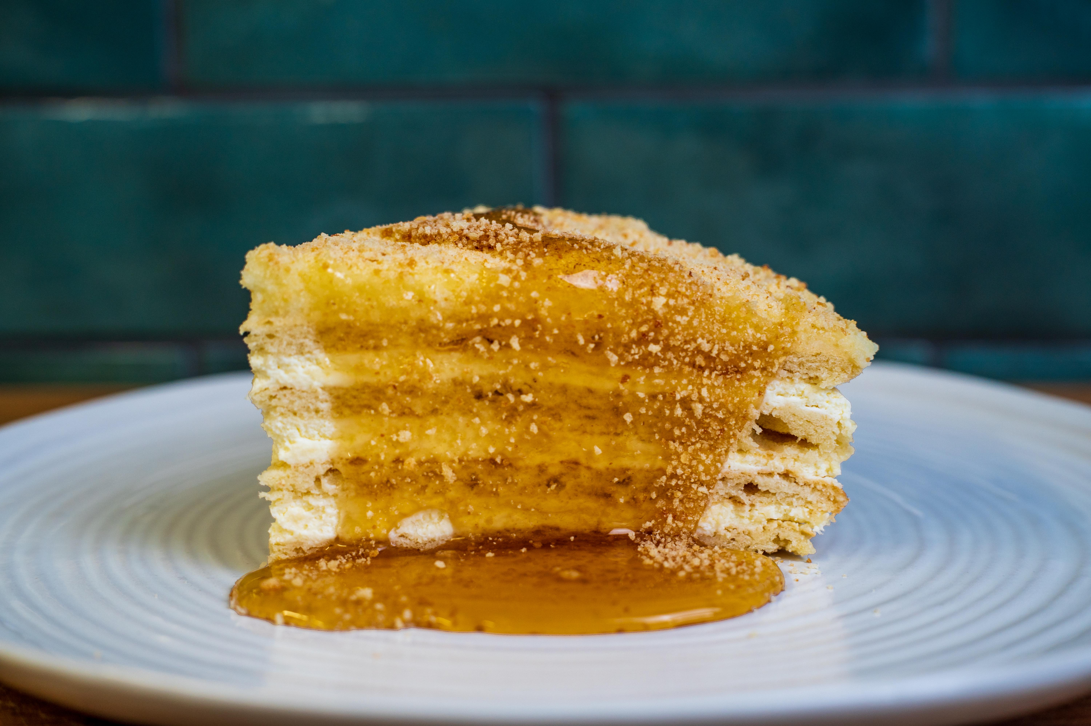

Full recipe including video: [https://cookwitheugene.substack.com/p/indulgent-russian-honey-cake](https://cookwitheugene.substack.com/p/indulgent-russian-honey-cake)  
  
# Ingredients:  
  
For the cake:  
  
* 75g unsalted butter  
* 100g granulated sugar  
* 5 tbsp honey  
* 3 large eggs  
* 1 tsp vanilla extract  
* 1 tsp baking soda  
* 350g all purpose flour  
  
For the frosting:  
  
* 250g mascarpone  
* 125ml double cream  
* 100g icing sugar  
* 1 tsp vanilla extract  
  
For the filling:  
  
* 500ml sour creme  
* 500ml double cream  
* 1 tsp vanilla extract  
* 50g icing sugar  
  
# Method:  
  
1. Go ahead and preheat your oven to 200°C / 400°F and prepare two baking trays with baking paper.  
2. After setting up a double boiler over a large pot of simmering water, melt the sugar, honey and butter in the bowl. Separately, beat the eggs and vanilla together and pour this mixture into the double boiler, constantly mixing to avoid creating your breakfast scrambled eggs.  
3. Next, add in the baking soda, salt and 2/3 of the flour, mixing until the dough begins to thicken, once it starts taking shape, take it off the heat and mix in the remaining flour.  
4. Let the dough cool a little bit and knead it with your hands to get to a smooth consistency. Divide into 8 equal parts and cover with a damp kitchen towel to avoid letting it dry out.  
5. Dust your work surface with some flour, and roll out a thin circle slightly bigger than the lid of your cake tin (approx. 23-25cm). Transfer to the baking tray and bake for 4-5mins, keeping an eye on the process as to not burn the layers. Repeat for the rest of the layers.  
6. As they turn golden brown, take them out the oven, and cut out a circle whilst they are still hot.  
7. For the filling, beat the sour creme and double cream, sugar and vanilla until the sugar is incorporated and the whole mixture has double in size. Fill each layer of the cake except for the top and sides.  
8. For the frosting, whisk the mascarpone with the icing sugar, vanilla and double cream until stiff peaks. Cover the top and optionally sides of the cake with the frosting.  
9. It is highly recommended to leave the cake sit in the fridge overnight or 24h before service to allow the layers to soak in the filling.

# Shrimp Infused Pasta Aglio e Oilo with Sous Vide Salmon

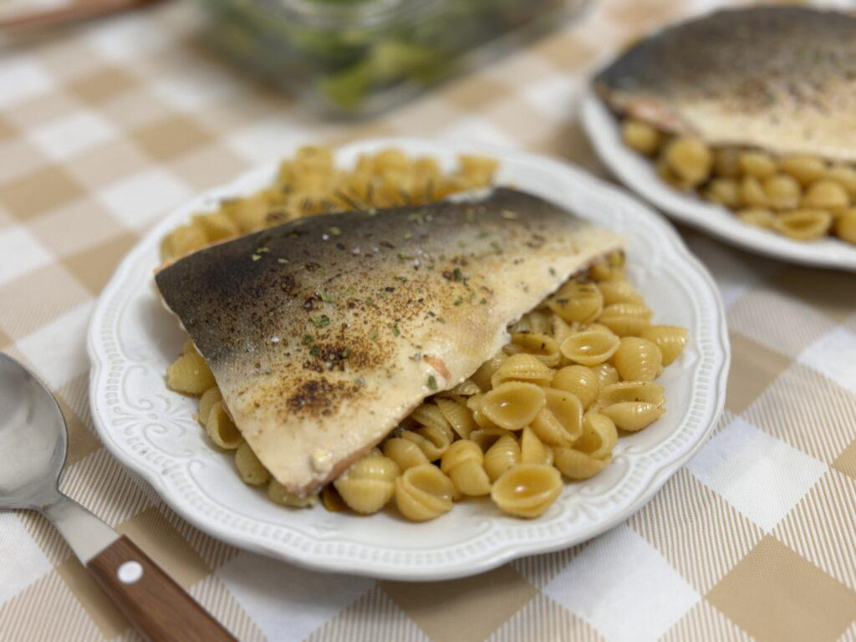

Full recipe: [https://servedwithrice.com/shrimp-infused-pasta-aglio-olio/](https://servedwithrice.com/shrimp-infused-pasta-aglio-olio/)   
  
**Ingredients (served 2):**   
  
*For the pasta*  
  
* Shrimp shells, saved from 1/2lb of shrimp  
* 150g pasta  
* 2 tbsp pasta water  
* 4 tbsp olive oil  
* Few cloves of garlic  
* Chilli flakes to taste  
* Herbs for garnish  
* Salt and pepper  
* Lemon juice and chili flakes to taste  
  
*For the salmon*   
  
* 2x 140g salmon filets  
* 0.5 tsp mixed dried herbs  
* Lemon juice, salt and pepper to taste  
  
**Instructions**   
  
1. Sous vide salmon pieces for 1 hour at 46C/115F  
2. Bring salted water to a boil. Cook pasta until al dente according to package instructions.  
3. Drain the pasta, saving some pasta water.  
4. Put olive oil in the pan on medium-low heat. Once hot, sauté shrimp shells until fragrant, then discard the shells.  
5. In the same pan, add dried chili flakes and garlic and sweat briefly, until aromatic. Switch off the heat.  
6. Add the pasta, pasta water, lemon juice and herbs. Stir until well combined.  
7. Top pasta with the salmon, and lightly torch the salmon skin.  
8. Garnish with more herbs and lemon juice. Serve hot.  
  
Cheers!

# Mustard and Maple Syrup Air Roasted Chicken Quarters with potatoes and onion

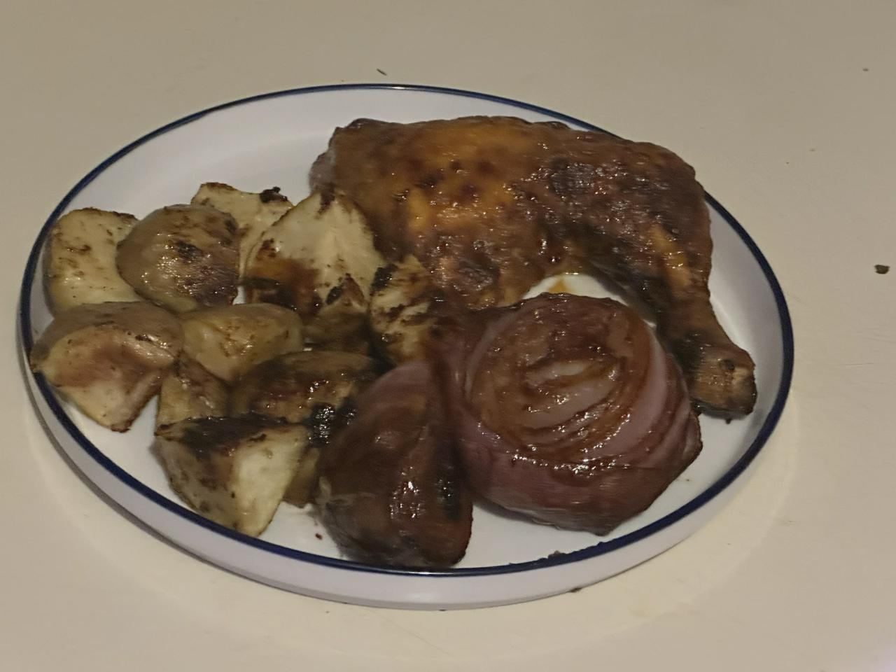

**Ingredients:**  
  
* 1 quarter chicken piece  
* 2 golden potatoes, cubed  
* 1 red onion, sliced in half  
* salt  
* pepper  
* accent (MSG)  
* garlic powder  
* herbs de Provence  
* 1/4 cup yellow mustard  
* 1/4 cup real maple syrup  
  
**Steps:**  
  
1. Preheat your air roaster on 350 for 45 minutes  
2. Season the chicken well with the dry ingredients  
3. mix the mustard and syrup together, and spread it onto the chicken  
4. Place chicken in pre-heated air roaster, add the potatoes and onions, and add a layer of glaze to the chicken every 10 minutes.  
5. Give a 5 minute blast at 450 on air fryer setting to help crisp up the skin.  
  
Always check temp at the joint or bone of at least 165 for safe consumption.

# Chawanmushi - savoury egg custard

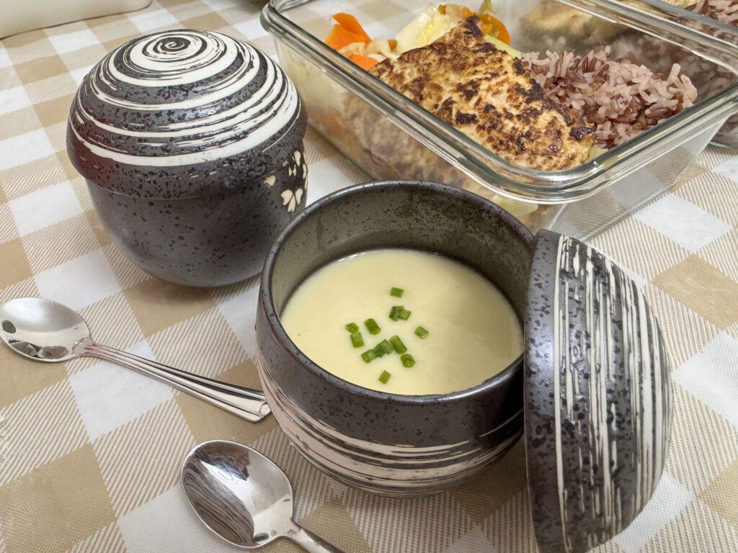

Full recipe: [https://servedwithrice.com/minimalist-chawanmushi/](https://servedwithrice.com/minimalist-chawanmushi/)   
  
**Ingredients (served 2):**   
  
* 2 dried shiitake mushrooms   
* Several pieces of dried scallop, about 10g  
* 60ml water from rehydrating shiitake and scallop  
* 1 egg  
* Scallion greens for garnish  
  
**Instructions**  
  
1. Separate the shiitake stems from caps. Give the shiitake and dried scallops a rinse.  
2. Rehydrate the shiitake and scallops in cold water overnight, or in boiling water for 30 minutes. Reserve the rehydrating liquid.  
3. Bring water to a boil. Meanwhile, finely dice the shiitake caps, shred the scallops, and place both at the bottom of the serving vessel.  
4. Beat the egg with an equal amount of rehydrating liquid, and strain into the serving vessel through a fine meshed sieve.  
5. Cover the top of the serving vessel with clingfilm, and poke a hole in the middle.   
6. Steam the eggs on low heat for about 15 minutes, or until barely set and wobbly.  
7. Serve hot.  
  
Cheers!